**Neural Network Back Propagation**

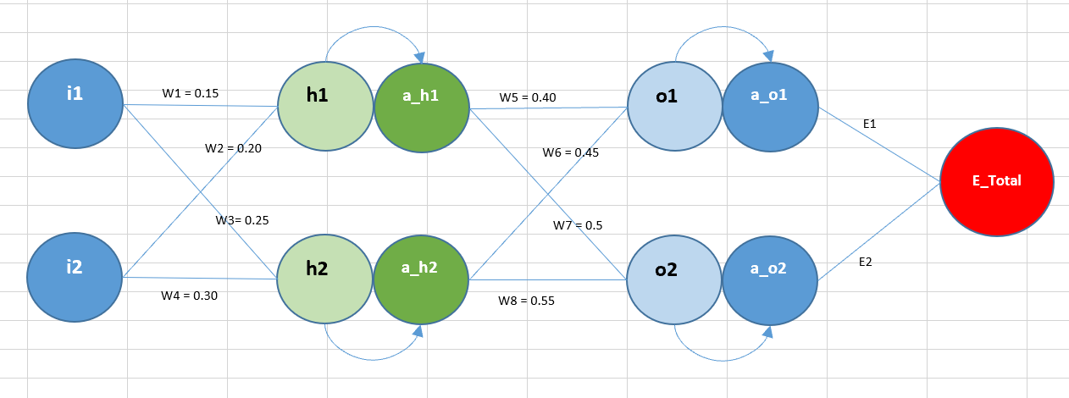

**NN parameters**

|  |
| --- |
| **h1 = w1*i1+w2*i2** |
| **h2 = w3*i1+w4*i2** |
| **a_h1 = σ(h1) = 1/(1+exp(-h1))** |
| **a_h2 = σ(h2)** |
| **o1 = w5*a_h1+w6*a_h2** |
| **o2 = w7*a_h1+w8*a_h2** |
| **a_o1 = σ(o1)** |
| **a_o2 = σ(o2)** |
| **E1 = ½*(t1-a_o1)²** |
| **E2 = ½*(t2-a_o2)²** |

**Partial Derivation on total loss wrt Weights of network**

|  |  |  |  |
| --- | --- | --- | --- |
|  |  |  |  |

1. **∂E_T/∂w5 =** ∂(E1+E2)/∂w5 = ∂E1/∂w5 = (∂E1/∂a_o1) * (∂a_o1/∂o1) * (∂o1/∂w5) ---- (1)

Now, ∂E1/∂a_o1 = (t1 - a_o1) * (-1) = ***a_o1 – t1*** *---- x*

∂a_o1/∂o1 = ∂(σ(o1))/ ∂o1 = σ(o1) * (1 - σ(o1)) = ***a_o1 * (1 – a_o1)*** *---- y*

∂o1/∂w5 = ∂(w5*a_h1+w6*a_h2)/ ∂w5 = **a_h1** ---- z

Substituting x, y and z in (1)

**∂E_T/∂w5 = (*a_o1 – t1) * (a_o1 * (1 – a_o1)) * (*a_h1)**

Similarly -

1. **∂E_T/∂w6 = (*a_o1 – t1) * (a_o1 * (1 – a_o1)) * (*a_h2)**
2. **∂E_T/∂w7 = (*a_o2 – t2) * (a_o2 * (1 – a_o2)) * (*a_h2)**
3. **∂E_T/∂w8 = (*a_o2 – t2) * (a_o2 * (1 – a_o2)) * (*a_h1)**
4. **∂E_T/∂a_h1 =** ∂(E1+E2)/∂a_h1 = ∂E1/∂a_h1 + ∂E2/∂a_h1 ---- (1)

∂E1/∂a_h1 = ∂E1/∂a_o1 * ∂a_o1/∂o1 * ∂o1/∂a_h1 ----l

∂E1/∂a_o1 = ***a_o1 – t1*** *---- m*

∂a_o1/∂o1 = ***a_o1 * (1 – a_o1)*** *---- n*

∂o1/∂a_h1 = ∂(w5*a_h1+w6*a_h2) /∂a_h1 = **w5** ----o

Substituting m, n, o in l

∂E1/∂a_h1 = **(*a_o1 – t1) * (a_o1 * (1 – a_o1)) * w5*** *--- x*

Similarly,

∂E2/∂a_h1 = **(*a_o2 – t2) * (a_o2 * (1 – a_o2)) * w7*** *---- y*

Substituting x, y in (1)

**∂E_T/∂a_h1 = (*a_o1 – t1) * (a_o1 * (1 – a_o1)) * w5 +*** (***a_o2 – t2) * (a_o2 * (1 – a_o2)) * w7***

1. **∂E_T/∂a_h2 = (*a_o2 – t2) * (a_o2 * (1 – a_o2)) * w8 +*** (***a_o1 – t1) * (a_o1 * (1 – a_o1)) * w6***
2. **∂E_T/∂w1 =** ∂E_T/∂a_h1 * ∂a_h1/∂h1 * ∂h1/∂w1 ---- (1)

∂a_h1/∂h1 = a_h1 * ( 1 – a_h1) -----x

∂h1/∂w1 = i1 ---- y

Substituting x, y in (1)

**∂E_T/∂w1 = ((*a_o1 – t1) * (a_o1 * (1 – a_o1)) * w5 +*** (***a_o2 – t2) * (a_o2 * (1 – a_o2)) * w7) * (a_h1 * ( 1 – a_h1) ) * i1***

Or

**∂E_T/∂w1 = *∂E_T/∂a_h1 * (a_h1 * ( 1 – a_h1) ) * i1***

1. **∂E_T/∂w2 = *∂E_T/∂a_h1 * (a_h1 * ( 1 – a_h1) ) * i2***
2. **∂E_T/∂w3 = *∂E_T/∂a_h2 * (a_h2 * ( 1 – a_h2) ) * i1***
3. **∂E_T/∂w4 = *∂E_T/∂a_h2 * (a_h2 * ( 1 – a_h2) ) * i2***